Advanced programming

# lab 2

## café e system

### Intoduction

A new restaurant in Islamabad wants to establish a niche by providing an online reservation system for their customers. The administration wants to use the same system to ensure optimal resource (servers, tables, time) allocation for any impromptu guests. The restaurant plans to stay open between 11:00am – 10:00pm. The customer can select any number of items and will be able to see a bill generated for all the selected items. Every delivery must happen with-in 30 minutes between the cafe opening time and 10:30pm.

### approach

To implement this, a menu is provided to user to select their desiring food. And he can select as many items as he can. In parallel, total bill amount is being calculated. After the user is done with order, a timeEstimate function is being called which provides the time when the order will be ready. User have option rather he/she wants to take way order or need delivery at home. According to User desire, food delivery functionality is processed. Order record manage through a database management. And also calculate bill by query.

I used maven project approach in this code and also check code through unit test.

### output sample

***Café Menu***

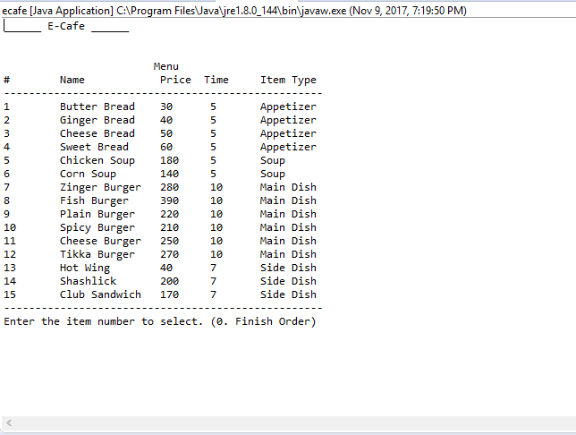

***Choose your Order***

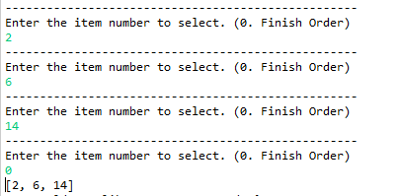

***Take away or home delivery***



***For take away***

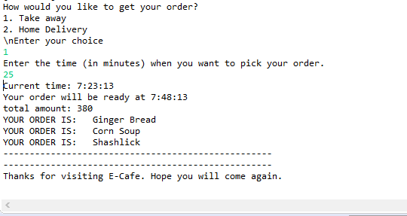

***For home delivery***

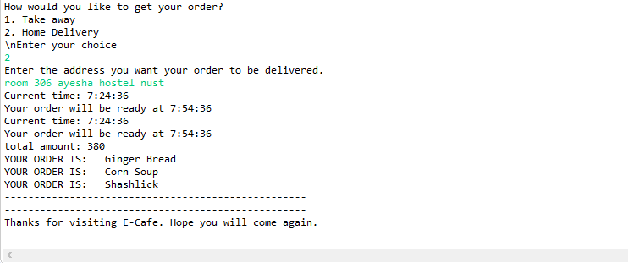

***Test for time estimation***

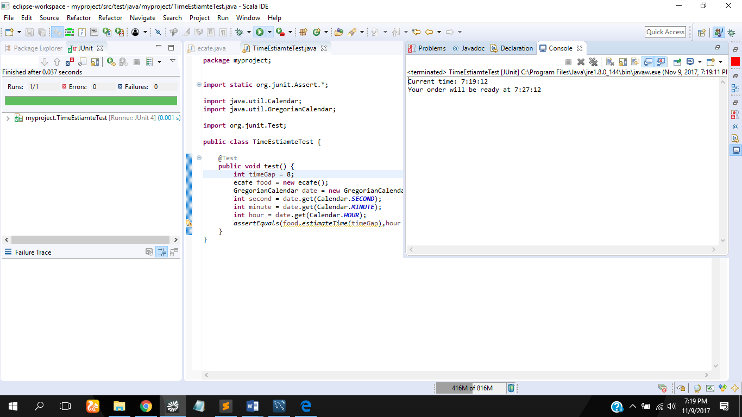

### github link

https://github.com/IqraRafiq/cafe-management